APP 300 – Special Topics
Appalachian Images & Interventions: Exploring
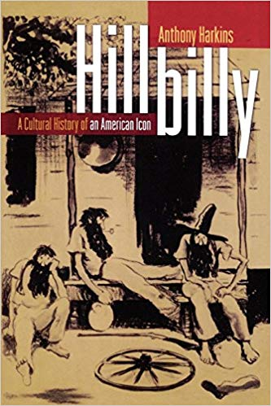
Media, Education, & Uplift in Modern America
TR 2:00-3:15PM
Erikson Hall 007
Carson Benn
Section 001
Prereq: APP 200 or consent of instructor.

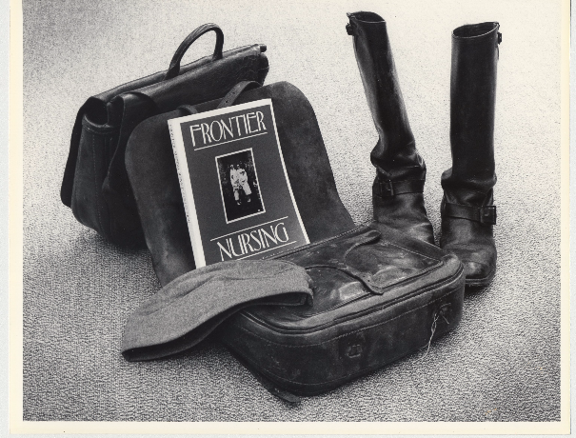
Appalachia appears in American media in a number of different ways, and many of these suggest that the mountains are in a state of poverty and social backwardness. In this class, we’ll read, watch, and listen to these media representations. We will consider the role Appalachia has played in the national consciousness and compare it to other places. We will then consider the relationship between media representations and the history of education and social aid in the region, from the second half of the nineteenth century up through the 2016 election. We ask: what has been tried in the past to uplift, educate, and "fix" the mountaineers, and what can we learn from the past as the region looks to construct new futures?
