Carson Benn
Sharing Work on Appalachia in Progress, Fall 2019

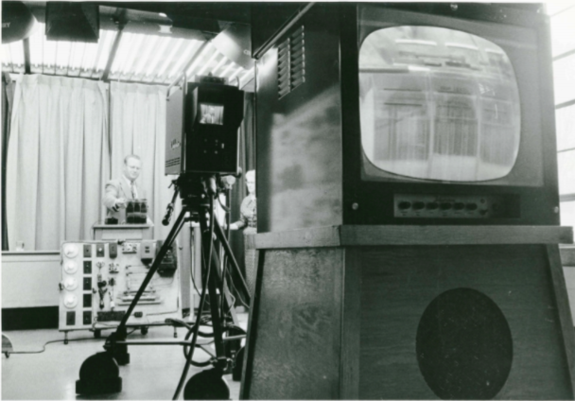

My research explores the early history of the public, educational television network of North Carolina, WUNC-TV, and serves as part of my dissertation project on public television service in the Appalachian region. One of the earliest educational television services in the United States, WUNC-TV initially offered its resources primarily to students and homes within a single channel range of the Consolidated University of North Carolina, in the state’s central, metropolitan area.

As the station developed its talents in producing educational programming through assistance from the state government and the Ford Foundation, educators beyond the reach of the station increasingly protested their exclusion from WUNC-TV’s benefits. Educators in regions like Appalachia, which had long faced disparities in funding and other resources, demanded not only that the mountains receive the broadcasts, but also that they be given equal place at the table in producing and designing the programs they would receive.

Through this process, WUNC-TV’s history serves as an insightful example of the measures educators can undertake to address divides between “educational centers” and peripheral regions long denied equal access to information, technology, and communication resources.

