Conducting community inventories of resources supporting healthy lifestyle among Appalachian residents
Presented by Madeline N. Dunfee, MD-PhD Student University of Kentucky
Mentor: Nancy E. Schoenberg; Department of Behavioral Science, University of Kentucky

Background:
- Appalachian residents experience high risk of lifestyle-related chronic diseases.
- Community assets include willingness to help neighbors.
- Barriers to maintaining a healthy lifestyle include few simple methods for identifying community resources to support healthy living.

Objective:
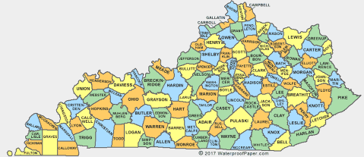
To determine the availability of healthy lifestyle resources, and to foster residents’ awareness of these resources by a) collaborating with community stakeholders to develop the Community Resource Assessment (CRA); b) exploring local perspectives on resources supporting health lifestyle by administering CRA to experts; and c) disseminating resource inventories though community programs.

Methods:
Setting: 15 counties in rural, southeastern Kentucky
Participants: 23 community experts in local lifestyle resources
- Recruited through purposive and snowball sampling
Procedures: Collaborated with community stakeholders to develop the Community Resource Assessment (CRA), a 14-item questionnaire consisting of open-ended questions.
- Interviewed community stakeholders using CRA.
- Recorded and transcribed interviews.
- Analyzed interviews using conventional content analysis.
- Developed county-level resource inventories for dissemination.
- Revised resource inventories based on feedback during member checking.

Findings:
Community inventories revealed differences in resource availability across counties.
Two themes emerged during conventional content analysis of transcripts:
- Widespread cultural shift to healthier living motivates program development.
- Despite funding and infrastructure constraints, collaborations across sectors fuel innovative and engaging programs.

Significance:
- Community Resource Assessment (CRA) facilitates efficient collection of information about community resources.
- Increased internet access among Appalachian communities helps residents connect with diverse resources.
- Information sharing among local organizations and across counties may complement increased access to mHealth programs in supporting healthy living in Appalachian communities.

Acknowledgements:
This research was supported by an Institutional Development Award (IDeA) from the National Institute of General Medical Sciences of the National Institutes of Health under grant number P30 GM127211. This project was also supported by the University of Kentucky Department of Behavioral Science and the James S. Brown Graduate Student Award for Research on Appalachia. The content is solely the responsibility of the authors. We express appreciation to all participants who contributed their expertise regarding resources for healthy living.

